Key information: GCSE Science
Dear Parents/Carers,
Please find the information we shared with you at parents evening below. The key message from us is that in order to be successful in Science, students should follow the ’20-minute rule’. They should spend 20 minutes every evening completing Educake, making notes on GCSE Pod using the template we provide or practicing their knowledge organisers. This is checked regularly by their teachers to ensure students are revising consistently and efficiently ahead of their exams.
Please do make sure you check the compulsory intervention dates for students at the end of this letter as these will mean your child will be at school until 5pm on that day. These sessions are designed to support your students in accessing exam questions successfully.
We hope that you find this useful. If you have any more questions please do not hesitate to ask the Science Team.

What is included in GCSE Science?
Students are entered for Edexcel Combined Science or separate Sciences. They will receive 2 GCSEs from Combined Science and 3 GCSEs from Separate Sciences. The specifications can be found here:
Combined Science https://qualifications.pearson.com/en/qualifications/edexcel-gcses/sciences-2016.html
Biology https://qualifications.pearson.com/en/qualifications/edexcel-gcses/sciences-2016.html#tab-Biology
Chemistry https://qualifications.pearson.com/en/qualifications/edexcel-gcses/sciences-2016.html#tab-Chemistry
Physics https://qualifications.pearson.com/en/qualifications/edexcel-gcses/sciences-2016.html#tab-Physics

These specifications document the key areas students need to cover. There is no coursework but as part of their GCSE they will cover ‘core practicals’ which they will also be tested on in the exams. They will sit six exams (2 in Biology, 2 in Chemistry and 2 in Physics) in May and June.

How should students revise for Science?
We are advocating a minimum of 20 minutes of Science per day. Between now and the summer this will equate to almost 38 hours of revision! This time should be spent wisely. Students should not just be reading or copying out of a revision guide as this is not helpful to them. In each 20 minute slot they should be completing one of the following activities:
- Using their knowledge organisers to ‘look, cover, write, check’. This ensures students are actively spending time memorising and mastering their knowledge in each area.
- Revisiting key information by watching videos on GCSEPod. They should make notes using the GCSE Pod template (this can be copied into their book and not printed). This ensures they are organising their notes in a useful way for revision.
- Practicing their knowledge by taking quizzes using an online tool called Educake. These quizzes may be set by their teacher or they can choose quizzes to practice themselves.
- Once knowledge has been mastered, practicing exam questions and going through the mark scheme making corrections.
Combined Science students have been allocated two educake quizzes and two sets of GCSE Pods to complete per week for Science. These quizzes and pods have been specially designed to ensure that students revisit knowledge from year 10 and year 11 topics consistently to help build their memory. This home learning is set on a Monday and due the following Monday.

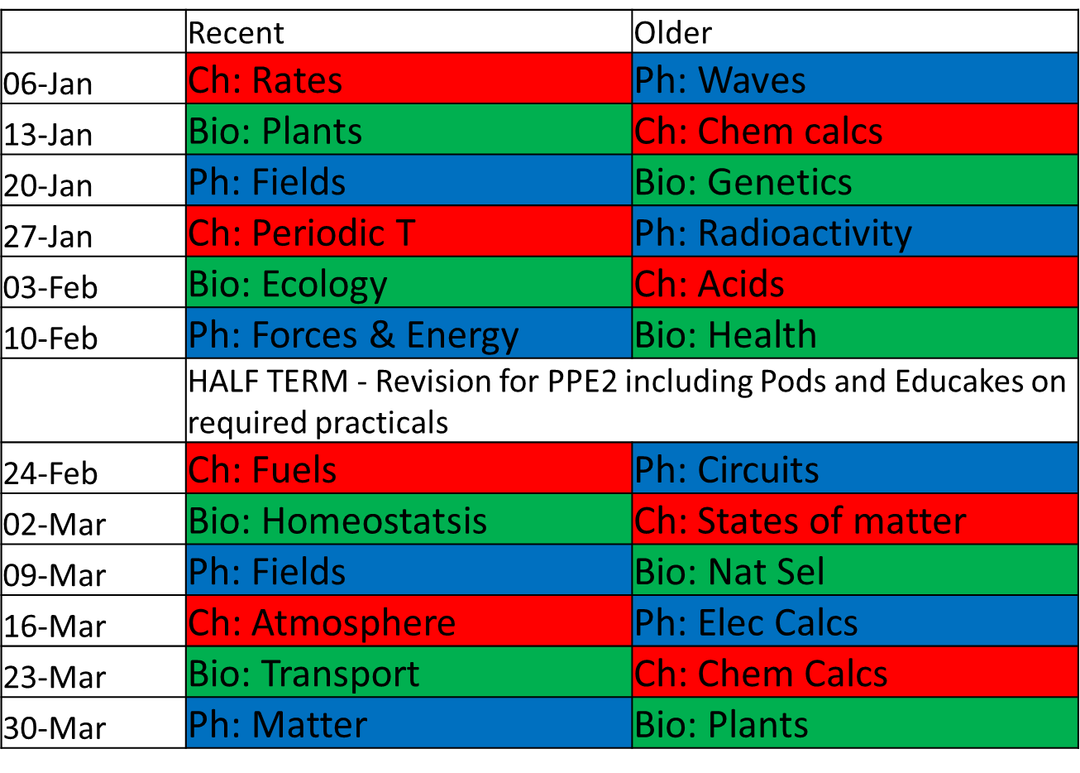

We issue 30 minute detentions on the Monday evening in a computer room so they can begin to complete what they have missed. In order for them not to get behind, we suggest they follow the following timetable:

Monday: GCSE Pod/s on a Year 10 topic
Tuesday: Practice knowledge organiser on this topic
Wednesday: Educake on this
Thursday: GCSE Pod/s on a year 11 topic
Friday: Practice knowledge organiser on this topic
Saturday: Educake on this topic
Sunday: Practice areas from the week they have not yet mastered.

What resources are available to support revision?
- All students have logins to GCSEPod and Educake.
- Each student will be provided with a pack of knowledge organisers with a tick sheet at the front that will support them in organising their time.
- Monday nights and Thursday lunchtimes Ms Bing and Mr Hilburn will be in ICT so students can complete online work if they do not have access to this at home.
- Students should regularly check their Office 365 page for their Science class for updates and support from their teacher.
- We have created a ‘Science revision page’ (located on Office 365 here; Office 365>Learning Resources>Documents>Science>KS4>Science Revision Page.url) that contains the following resources:
  - Online knowledge organisers
  - Links to video channels
  - Links to GCSE Pod/Educake
  - Topic checklists
  - Exam questions and mark schemes
  - Online walk and talk mocks
  - Practical information on ‘core practicals’

Are there any extra interventions taking place?
Yes. The following intervention sessions are running from now until the exam.

Which subject? | When? | Where?
Triple Physics | Tuesday Lunchtimes | Sci 1, MB
Triple Chemistry | Wednesday week 1 3:30-4:30pm  Tuesday Week 2 8:00-8:40am | Sci 9, AL  Sci 10, RO
Triple Biologists | Wednesday Week 2 3:30-4:30pm | Sci 7, SN
Combined Science | Friday lunchtimes  Friday 3:30-4:30pm | Sci 2, AZ  Sci 1/Hall AB

We will also be running a series of walk and talk mocks. There will be some during lesson time as part of the run up to the exams. Ms Bing will also be running walk and talk sessions on the following days as part of intervention:

7th February 3:30-5pm (Biology for Combined Science but also applicable to triple)
6th March 3:30-5pm (Chemistry for Combined Science but also applicable to triple)
27th March 3:30-5pm (Physics for Combined Science but also applicable to triple)

These are compulsory for combined Science students.

Higher or foundation tier?
The foundation paper can be graded from grade 1 to a grade 5 (a high C/low B) and contains low-medium demand questions. The higher paper can be graded from 4 (low C)-9 and contains medium-high demand questions.

We entered a majority of our students for higher tier in the November PPEs to assess whether this would be the most appropriate paper for them. Those students who received a grade less than 5 will be considered for the foundation papers based on advice we have received from the exam boards and our experience in previous exams.

In order for them to stay on higher, those that achieved a 4 or 5 will need to perform just as well in the second round of PPEs, ideally better, for us to keep them on higher tier. Those students that achieved less than 4 would not receive a grade in the real exam and we will therefore place them on foundation for the 2nd PPE and their real exam.

We hope that you have found this useful. If you have any more questions please do not hesitate to ask the Science Team.

